**EXPERIMENT NO: - 03**

Aim: - Write Python Program to Implement Quick Sort.

Name: - Nishant Bhandari

Roll No: - 06

Subject:- Fundamental Algorithm

Class: - SY-CS

Sign: -

**Source code: -**

def quicksort(x):

if len(x) == 1 or len(x)==0:

return x

else:

pivot =x[0]

i=0

for j in range (len(x)-1):

if x[j+1] < pivot:

x[j+1],x[i+1] = x[i+1],x[j+1]

i+=1

x[0],x[i]=x[i],x[0]

first_part = quicksort(x[:i])

second_part = quicksort(x[i+1:])

first_part.append(x[i])

return first_part + second_part

alist =[54,26,93,17,77,31,44,55,20]

print(quicksort(alist**))**

**Output: -**

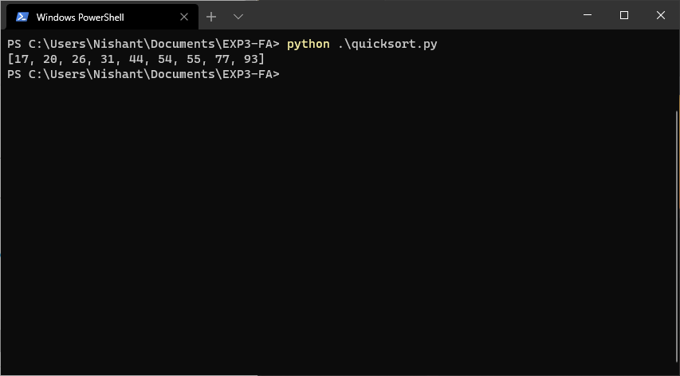

**Conclusion: Thus, we have studied about how to** **Implement Quick Sort**.